Appendix A

Review of Treasury Management 2013/14

Introduction

The County Council’s treasury management activity is underpinned by CIPFA’s Code of Practice on Treasury Management (“the Code”), which requires authorities to produce annually Prudential Indicators and a Treasury Management Strategy Statement on the likely financing and investment activity. The Code also recommends that members are informed of treasury management activities at least twice a year.

- Economic Summary 2013/14

At the beginning of the 2013-14 financial year markets were concerned about lacklustre growth in the Eurozone, the UK and Japan. Lack of growth in the UK economy, the threat of a ‘triple-dip’ alongside falling real wages (i.e. after inflation) and the paucity of business investment were a concern for the Bank of England’s Monetary Policy Committee. Only two major economies – the US and Germany – had growth above pre financial crisis levels, albeit these were still below trend. The Eurozone had navigated through a turbulent period for its disparate sovereigns and the likelihood of a near-term disorderly collapse had significantly diminished. The US government had just managed to avoid the fiscal cliff and a technical default in early 2013, only for the problem to re-emerge later in the year.
With new Governor Mark Carney at the helm, the Bank of England unveiled forward guidance in August pledging to not consider raising interest rates until the International Labour Organisation (ILO) unemployment rate fell below the 7% threshold. In the Bank’s initial forecast, this level was only expected to be reached in 2016. Although the Bank stressed that this level was a threshold for consideration of rate increase rather an automatic trigger, markets began pricing in a much earlier rise than was warranted and, as a result, gilt yields rose aggressively.
The recovery in the UK surprised with strong economic activity and growth. Quarter 4 2014 Gross Domestic Product (GDP) showed year-on-year growth of 2.7%. Much of the improvement was down to the dominant service sector, and an increase in household consumption buoyed by the pick-up in housing transactions which were driven by higher consumer confidence, greater availability of credit and strengthening house prices which were partly boosted by government initiatives such as Help-to-Buy. However, business investment had yet to recover convincingly and the recovery was not accompanied by meaningful productivity growth. Worries of a housing bubble were tempered by evidence that net mortgage lending was up by only around 1% annually.
The Consumer Price Index (CPI) fell from 2.8% in March 2013 to 1.7% in February 2014, the lowest rate since October 2009, helped largely by the easing commodity prices and discounting by retailers, reducing the pressure on the Bank to raise rates. Although the fall in unemployment (down from 7.8% in March 2013 to 7.2% in January 2014) was faster than the Bank of England or indeed many analysts had forecast, it hid a stubbornly high level of underemployment. Importantly, average earnings growth remained muted and real wage growth (i.e. after inflation) was negative. In February the Bank stepped back from forward guidance relying on a single indicator – the unemployment rate – to more complex measures which included spare capacity within the economy. The Bank also implied that when official interest rates were raised, the increases would be gradual – this helped underpin the ‘low for longer’ interest rate outlook despite the momentum in the economy.
The Office of Budget Responsibility’s 2.7% forecast for economic growth in 2014 forecast a quicker fall in public borrowing over the next few years. However, the Chancellor resisted the temptation to spend some of the proceeds of higher economic growth. In his 2013 Autumn Statement and the 2014 Budget, apart from the rise in the personal tax allowance and pension changes, there were no significant giveaways and the coalition’s austerity measures remained on track.
The Federal Reserve’s then Chairman Ben Bernanke’s announcement in May that the Fed’s quantitative easing (QE) programme may be ‘tapered’ caught markets by surprise. Investors began to factor in not just an end to QE but also rapid rises in interest rates. ‘Tapering’ (a slowing in the rate of QE) began in December 2013. By March 2014, asset purchases had been cut from $75bn to $55bn per month with expectation that QE would end by October 2014. This had particular implications for global markets which had hitherto benefited from, and got very accustomed to, the high levels of global liquidity afforded by QE. The impact went further than a rise in the dollar and higher US Treasury bond yields. Gilt yields also rose as a consequence and emerging markets, which had previously benefited as investors searched for yield through riskier asset, suffered large capital outflows in December and January.
With the Eurozone struggling to show sustainable growth, the European Central Bank (ECB) cut main policy interest rates by 0.25% to 0.25% and the deposit rate to zero. Markets were disappointed by the lack of action by the ECB despite CPI inflation below 1% and a looming threat of deflation. Data pointed to an economic slowdown in China which, alongside a weakening property market and a highly leveraged shadow banking sector, could prove challenging for its authorities.
Russia’s annexation of the Ukraine in March heightened geopolitical tensions and risk. The response from the West which began with sanctions against Russia which is the second largest gas producer in the world and which supplies nearly 30% of European natural gas needs and is also a significant supplier of crude oil – any major disruption to their supply would have serious ramifications for energy prices.
Gilt Yields and Money Market Rates: Gilt yields ended the year higher than the start in April. The peak in yields was during autumn 2013. The biggest increase was in 5-year gilt yields which increased by nearly 1.3% from 0.70% to 1.97%. 10-year gilt yields rose by nearly 1% ending the year at 2.73%. The increase was less pronounced for longer dated gilts; 20-year yields rose from 2.74% to 3.37% and 50-year yields rose from 3.23% to 3.44%.
3-month, 6-month and 12-month London interbank bid rates (LIBID) remained at levels below 1% through the year.

2. Change to Legislation: Bank Regulation and Bail-in

Bondholders are being required in the future to forfeit part of their investment to bail in a bank before tax payers are called upon to bail it out. So far bond holders have been untouched as equity holders have an obligation to pay their creditors.

A bail-in takes place before a bankruptcy and under current proposals; regulators would have the power to impose losses on bondholders while leaving untouched other creditors of similar stature, such as derivatives counterparties.

There is an EU Bank Recovery and Resolution Directive (Proposal 2013 – due for implementation January 2016) which proposes that national regulators will be required to bail-in creditors in order of seniority until their losses reach at least 8% of the bank’s liabilities before any government money can be injected.

Many liabilities are exempt from bail-in such as:-

• insured retail and small business deposits, interbank lending with a maturity of less than one week, secured debt such as covered bonds or Asset backed securities

This would leave local authority and other large deposits as one of the few categories able to take losses. For example, if unsecured bonds and wholesale deposits make up just 20% of the balance sheet, they will need to:

- take a cut of 40% to write down 8% of total liabilities
- Governments can then contribute up to 5% of the failing bank’s liabilities

If further funds are required, these must come from deeper cuts on unsecured creditors. It will be illegal for any more government money to be injected until bondholders and wholesale depositors were completely wiped out.

In December 2013 it became law that investor bail-ins will now replace government bail-outs in the UK as per the Financial Services (Banking Reform) Act 2013.

In summary, from a Local Government treasury management perspective, the maximum risk investment policy is to exclusively invest reserves and balances in the form of bank deposits directly or through money market funds where the funds investment strategy is predominately bank deposit or certificate of deposit (CD) based, in this case a Councils full investment portfolio will be "at risk" in the event of a credit event.

LCC has had a deliberate "low credit risk" investment policy in place for a number of years, replacing bank deposits with bonds issued by governments, government agencies, government guaranteed bodies, supranational bodies and collateralized bonds in the main. LCCs position is therefore substantially insulated from the effects of this legislation in the event of an individual or systemic banking "credit event".

Evidence of this low credit risk can be seen in the results of the Arlingclose benchmarking shown in the Appendices.

3. Treasury Management Strategy 2013/14

The Full Council approved the 2013/14 treasury management strategy at its meeting on 11th February 2013. The Council’s stated investment priorities were:

(a) Security of capital and
(b) Liquidity of its investments.

The Council also aimed to achieve the optimum return on its investments commensurate with proper levels of security and liquidity. The risk appetite of the Council is low in order to give priority to security of its investments.

The Council’s stated borrowing strategy was to take advantage of historically low short term interest rates by borrowing short term in the money markets rather than financing capital expenditure through long term Public Works Loan Board (PWLB) loans.

The County Treasurer can report that all treasury management activity undertaken during the financial year complied with the CIPFA Code of Practice and the relevant legislative provisions.

4. Treasury Management Activities in 2013/14

Borrowing Activity 2013/14

The revised 2013/14 borrowing requirement was estimated at £227.339m after taking into account the updated capital programme and the refinancing of existing borrowing, including short term borrowing taken to meet the Capital Financing Requirement. The table below shows the 2013/14 revised borrowing requirement as agreed within the 2014/15 treasury management strategy report, along with the actual position as at 31st March 2014.

 | 2013/14 Revised | 2013/14  Actual | 2014/15 Estimate
 | £m | £m | £m
Capital Programme Expenditure | 163.657 | 154.476 | 204.733
Financed by:  Capital Receipts | 0.983 | 0 | 0
Grants and Contributions | 147.437 | 138.086 | 146.850
Revenue Contributions | 13.337 | 16.390 | 14.001
Borrowing | 1.900 | 0 | 43.882
Add Maturing Debt to be replaced:
Long Term PWLB | 0 | 0 | 0
Short Term Market Borrowing | 264.700 | 264.700 | 264.700
Less Transferred Debt | 2.033 | 2.033 | 1.967
Less Statutory Charge to Revenue | 37.228 | 27.285 | 35.655
Total Borrowing Requirement | 227.339 | 235.382 | 270.960

The revised capital programme estimated that £1.9m of new borrowing would be required to finance the capital programme. However lower than anticipated capital expenditure meant this borrowing was not required.

Analysis of Debt Outstanding

The following table sets out the structure of the County Council’s debt at 31st March 2014.

 | Debt at |  | Borrowing | Repayments | Debt at
 | 31-Mar-13 |  |  |  | 31-Mar-14
 | £m | % | £m | £m | £m | %
Fixed Rate Funding
Public Works Loan Board | 213.10 | 26.04 | - | - | 213.10 | 26.22
*LOBO (RBS) | 50.00 | 6.31 | - | - | 50.00 | 6.15
Local Bonds | 0.02 | - | - | - | 0.02 | -
Market Borrowing | 287.25 | 37.22 | 732.70 | 689.00 | 330.95 | 40.73
 | 550.37 |  | 732.70 | 689.00 | 594.07
Variable Rate Funding
Public Works Loan Board | 125.75 | 22.70 | - | - | 125.75 | 15.48
Shared Investment Scheme | 61.49 | 7.73 | 527.09 | 495.81 | 92.77 | 11.42
 | 187.24 |  | 527.09 | 495.81 | 218.52
Loan Debt Administered by the County Council | 737.62 | 100.00 | 1,259.786 | 1,184.809 | 812.59 | 100.00
*Lender option borrower option

The total loan debt administered by the County Council at 31 March 2014 of £812.59m represents mainly borrowings over the years to finance the acquisition of the County Council’s fixed assets, which are currently valued at £2.671 billion.

With short-term interest rates having remained much lower than long-term rates, it was more cost effective in the short-term to borrow short-term loans from the market, mainly from other local authorities. By doing so, the Council was able to keep borrowing costs low and reduce overall treasury risk. Whilst such a strategy is most likely to be beneficial over the next 2-3 years as official interest rates remain low, it is unlikely to be sustained in the medium-term.

The County Treasurer will, in conjunction with Arlingclose, continue to closely monitor interest rate forecasts in order to establish when long term interest rates might be expected to rise.

Overall the average rate of interest paid in 2013/14 on the debt administered by the County Council was 2.48% per annum compared with an average rate of 2.45% in 2012/13, 2.11% in 2011/12 and 2.69% in 2010/11.

The charts below show the maturity and portfolio profiles of the County Council's debt as at 31 March 2014.

Investment Activity

The total amount of investments (excluding fair value adjustment) held by Lancashire County Council at 31st March 2014 is £587.07m including £57.748m of cash and cash equivalents. The table below shows the asset classes and the proportion of investments held in each class.

The table below shows a maturity analysis of the portfolio at 31st March 2014, alongside the average interest rate earned over the 2013/14 financial year.

Maturity Range | Amount £m | Average Rate %
Call, Money Market Funds & Under 1yr | 77.75 | 1.23
Bank Deposit 1-2 Years | 73.68 | 2.98
Bank and Local Authority Deposits 2-3 Years | 10.00 | 1.00
Bank & Local Authority Deposits 3-5 Years | 36.50 | 0.43
Bank Deposit 5 Years + | - | -
Local Authority Bonds | 20.31 | 6.23
UK Government and Supranational Bonds | 368.83 | 2.75
Total | 587.07 | 2.56

Investments by Maturity

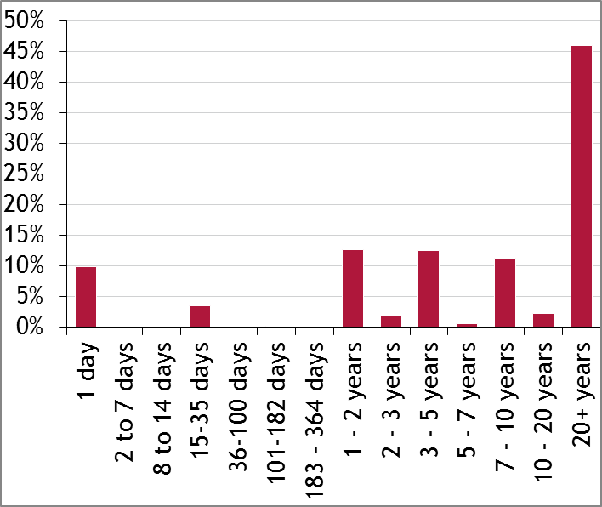

Total investments analysed by asset type

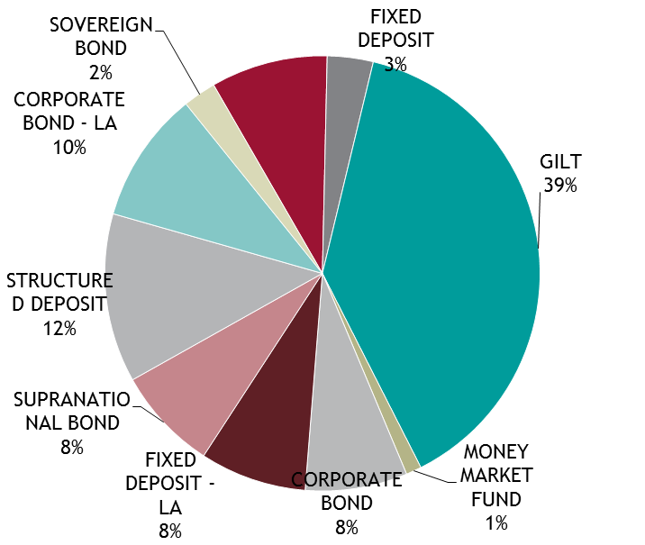

Total Investments analysed by credit rating

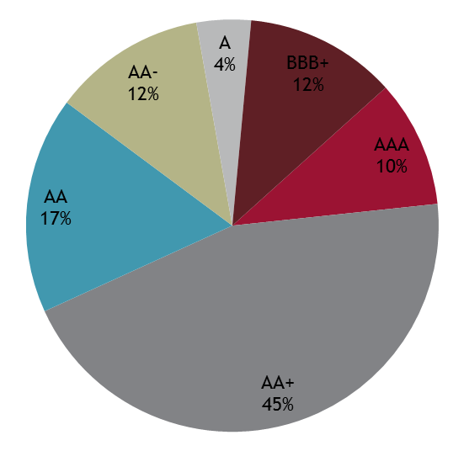

Investments are very secure, with 55% rated AAA or AA+, although £69m with RBS Group is rated below BBB+. Average credit score of 2.82/AA is well within the limit of
5/A+

Security of capital remained the Council’s main investment objective. This was maintained by following the Council’s counterparty policy as set out in its Treasury Management Strategy Statement for 2013/14. This defined “high credit quality” organisations as those having a minimum long-term credit rating of A+ In practice the average credit rating in 2013/14 was higher at AA.

Investments with banks and building societies were primarily call accounts, money market funds and fixed-rate term deposits. The longest duration of bank deposit currently carried by the County Council is 15 months. Any longer term deposits have been restricted to other local authorities.

Credit developments and credit risk management
The Council assessed and monitored counterparty credit quality with reference to credit ratings; credit default swaps; GDP of the country in which the institution operates, the country’s net debt as a percentage of GDP and share price.

The debt crisis in Cyprus was resolved by its government enforcing a ‘haircut’ on unsecured investments and bank deposits over €100,000. This resolution mechanism, in stark contrast to the bail-outs during the 2008/2009 financial crisis, sent shockwaves through Europe but allowed banking regulators to progress reform which would in future force losses on investors through a ‘bail-in’ before taxpayers were asked to support failing banks.

The Financial Services (Banking Reform) Act 2013 gained Royal Assent in December, legislating for the separation of retail and investment banks and for the introduction of mandatory bail-in in the UK to wind up or restructure failing financial institutions. EU finance ministers agreed further steps towards banking union, and the Single Resolution Mechanism (SRM) for resolving problems with troubled large banks which will shift the burden of future restructurings/rescues to the institution’s shareholders, bondholders and unsecured investors.

Proposals were also announced for EU regulatory reforms to Money Market Funds which may result in these funds moving to a VNAV (variable net asset value) basis and losing their ‘triple-A’ credit rating wrapper in the future.

The material changes to UK banks’ creditworthiness were (a) the strong progress made by the Lloyds Banking Group in strengthening its balance sheet, profitability and funding positions and the government reducing its shareholding in the Group to under 25%, (b) the announcement by Royal Bank of Scotland of the creation of an internal bad bank to house its riskiest assets (this amounted to a material extension of RBS’ long-running restructuring, further delaying the bank’s return to profitability) and (c) substantial losses at Co-op Bank which forced the bank to undertake a liability management exercise to raise further capital and a debt restructure which entailed junior bondholders being bailed-in as part of the restructuring.

In July Moody’s placed the A3 long-term ratings of Royal Bank of Scotland and NatWest Bank and the D+ standalone financial strength rating of RBS on review for downgrade amid concerns about the impact of any potential breakup of the bank on creditors. As a precautionary measure the Council reduced its duration to overnight for new investments with the bank(s). In March Moody’s downgraded the long-term ratings of both banks to Baa1. As this rating is below the Council’s minimum credit criterion the banks were withdrawn from the counterparty list for further investment. NatWest is the Authority’s banker and will continue to be used for operational and liquidity purposes.

Credit risk Analysis

The Appendices show Arlingclose's quarterly credit risk benchmarking of their clients. The graphs show that LCC is in line with its' strategy of low credit risk and high investment return. They also show that LCC compare favourably to other organisations.

Liquidity Management
In keeping with the CLG’s Guidance on Investments, the Council maintained a minimum level of primary liquidity of £20.0m through the use of Money Market Funds and Call Accounts. The Council also has £368m bond portfolio which is available for sale, at current market prices, if needed as “secondary” liquidity.

The Council uses purpose-built cash flow forecasting spreadsheets to determine the maximum period for which funds may prudently be committed.

Yield
The UK Bank Rate was maintained at 0.5% through the year. Short term money market rates also remained at very low levels which continued to have a significant impact on investment income. The average 3-month LIBID rate during 2013/14 was 0.45%, the 6-month LIBID rate averaged 0.53% and the 1-year LIBID rate averaged 0.78%. The low rates of return on the Authority’s short-dated money market investments reflect prevailing market conditions and the Authority’s objective of optimising returns commensurate with the principles of security and liquidity.

Income earned of £16.2m on longer-dated investments made in 2013/14, an average rate of 2.68%, providing some cushion against the low interest rate environment.

4. Impact of the Treasury Management Strategy on the County Council's revenue budget

The table below shows an underspend of £1.528m on the finance charges budget which is as a result of the Treasury Management strategy applied in the year. This has been achieved by keeping borrowing costs low and maximising investment returns whilst ensuring the proper levels of security and liquidity are maintained.
Financing Charges 2013/14– End of Year Position

 | Budget | Year End Position | Variance
 | £m | £m | £m
Statutory Charge to Revenue | 29.998 | 30.565 | 0.567
Interest paid | 18.674 | 19.278 | 0.604
Investment interest received | -16.323 | -19.022 | -2.699
Total Net Financing charges | 32.349 | 30.906 | -1.528

5. Treasury Management and Prudential Indicators 2013/14

The Local Government Act 2003 and supporting regulations require the County Council to have regard to the prudential code and to set prudential indicators to ensure the County Council's capital investment plans are affordable, prudent and sustainable.

A comparison of the actual position at 31 March 2013 compared to the indicators set in the treasury management strategy for 2012/13 is set out below.

2013/14 2013/14
Limit Actual
£m £m
Prudential Indicators

- Adoption of CIPFA TM Code of Practice ADOPTED

- Authorised limit for external debt - A prudent estimate of debt,
which reflects the Authority’s capital expenditure plans and allows
sufficient headroom for unusual cash movements.

Borrowing 891 815

Other long-term liabilities (PFI schemes) 500 395

TOTAL 1,391 1,210

- Operational boundary for external debt - A prudent estimate
of debt, but no provision for unusual cash movements. It
represents the estimated maximum external debt arising as
a consequence of the County Council's current plans.

Borrowing 841 815

Other long-term liabilities (PFI schemes) 450 395

TOTAL 1,291 1,210

- Indicators of Capital Expenditure and Financing

Capital Programme Expenditure 166 154

Capital Financing Requirement 1,019 1,038

Ratio of Gross Debt to CFR* 124% 127%

*Gross borrowing appears higher than the capital financing requirement because the shared investment scheme is accounted for as borrowing, but it does not form part of the capital financing requirement calculation.

- Council Tax indicators

Ratio of financing costs to the net revenue stream 6.59% 3.97%

Estimated revenue impact of capital investment on Band D 89.01 49.42
Council Tax

Treasury Management Indicators

- Upper limit for fixed rate debt 37.6 - 0.3

- Upper limit for variable rate debt 5.0 0.1

- Upper limit for Bank Deposits over 364 days

This limit does not apply to UK or AAA rated foreign Government 75% 13%
or Supra National Bank securities.

- Maturity structure of debt

 |  | Lower Limit % | Upper Limit % | Actual %
Under 12 months | - |  | 75 | 46.5
12 months and within 2 years | - |  | 75 | 1.8
2 years and within 5 years | - |  | 75 | 2.8
5 years and within 10 years | - |  | 75 | 21.1
10 years and above | 25 |  | 100 | 27.8

The Council confirms that it has complied with its Prudential Indicators for 2013/14, which were approved on 11th February 2013 as part of the Council’s Treasury Management Strategy Statement.

The Council also confirms that during 2013/14 it complied with its Treasury Management Policy Statement and Treasury Management Practices.

- Investment in Landsbanki is.

Lancashire County Council had £6.4m on deposit with the Icelandic Bank Landsbanki (LBI) when it collapsed in October 2008. The Winding up Board published details of LBI's financial position as at 31 December 2012; this showed that LBI's assets, including partial payments already made in respect of priority claims were greater than the sum of priority claims. It is therefore still considered likely that UK local authorities will recover 100% of their deposits, subject to potential future exchange rate fluctuations. Approximately 53% of the total claim has now been repaid and the outstanding amount at 31 March 2014 is £3.1m.

The exact timing and amounts of future distributions is not known at this stage.

The deposit is treated as an impaired asset on the balance sheet and the carrying value is written down as distributions are received.

Appendices

